LAN Engineer sebuah Gedung berlantai 3 ingin mendesain jaringan menggunakan Cisco Packe Tracer sebagai berikut :

1. Tiap lantai dibuat jaringan dengan infrstruktur sebagai berikut : 1 router yang terhubung ke 2 switch. Masing-masing switch terhubung ke 3 workstation/client dan memiliki 1 acess point dan 1 printer sharing
2. Workstation/client setiap lantai hanya dapat mengakses printer di lantainya masing-masing
3. Hubungkan jaringan lantai 1, lantai 2, dan lantai 3

**Topologi Jaringan**

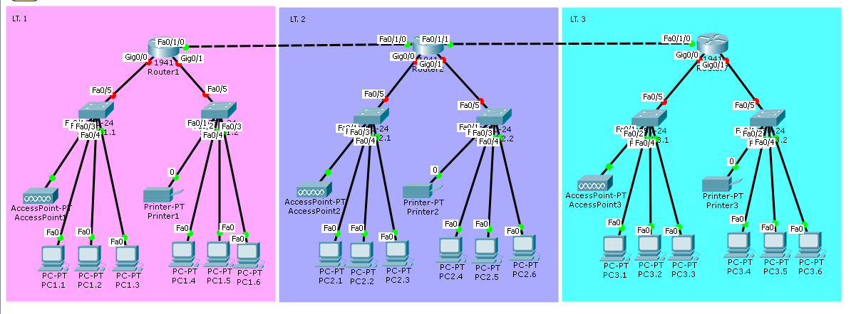

**Tabel Konfigurasi IP Address**

|  |  |  |  |  |  |  |  |
| --- | --- | --- | --- | --- | --- | --- | --- |
| **LT. 1** | | | | | | | |
| **SWITCH 1.1** | | | | **SWITCH 1.2** | | | |
| Port | Device Name | IP Address | Port | | Device Name | IP Address |
| Fa0/1 | AccessPoint1 |  | Fa0/1 | | Printer1 |  |
| Fa0/2 | PC1.1 |  | Fa0/2 | | PC1.4 |  |
| Fa0/3 | PC1.2 |  | Fa0/3 | | PC1.5 |  |
| Fa0/4 | PC1.3 |  | Fa0/4 | | PC1.6 |  |
| Fa0/5 | Router1 (Gig0/0) | - | Fa0/5 | | Router1 (Gig0/1) | - |
| **LT. 2** | | | | | | | |
| **SWITCH 2.1** | | | | **SWITCH 2.2** | | | |
| Port | Device Name | IP Address | Port | | Device Name | IP Address |
| Fa0/1 | AccessPoint2 |  | Fa0/1 | |  |  |
| Fa0/2 | PC2.1 |  | Fa0/2 | |  |  |
| Fa0/3 | PC2.2 |  | Fa0/3 | |  |  |
| Fa0/4 | PC2.3 |  | Fa0/4 | |  |  |
| Fa0/5 | Router2 (Gig0/0) |  | Fa0/5 | |  |  |
| **LT. 3** | | | | | | | |
| **SWITCH 3.1** | | | | **SWITCH 3.2** | | | |
| Port | Device Name | IP Address | Port | | Device Name | IP Address |
| Fa0/1 |  |  | Fa0/1 | |  |  |
| Fa0/2 |  |  | Fa0/2 | |  |  |
| Fa0/3 |  |  | Fa0/3 | |  |  |
| Fa0/4 |  |  | Fa0/4 | |  |  |
| Fa0/5 |  |  | Fa0/5 | |  |  |